Playground Rules and Expectations

Rules we teach
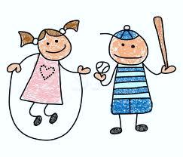
Run on GRASS only No touch policy at Nate Mack Stairs for feet, bars for arms One student on slide, feet first, on pockets
Playground bells & whistle
Bell rings and students freeze Teacher blows whistle three times to remind students to WALK,WALK, WALK to classroom line
Children on the playground
Children younger than kinder age, please keep within arms reach at all times. Older students are directed to go to the intermediate playground.
**Please support teachers in keeping the playground a safe place. If you see something that needs correction, gently ask child to correct behavior. If needed, please alert the teacher on duty as well.

