Nate Mack Administration

 

Mrs. Epperson

Vice-Principal

Mrs. Heavey

Principal

Nate Mack Specialists

 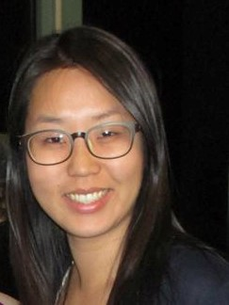  

Ms. Hermanny Miss Joo Sin Coach Spencer Ms. Juliano

Art Music P.E. Library STEM

 

Ms. Harris Ms. Leah

Library STEM Aide P.E. Aide